Construya el índice hash dinámico (árbol digital) a partir de los siguientes datos:

**Keys: 2, 3, 7, 8, 9, 12, 15, 18, 20, 21, 25, 33, 38, 47, 54, 61, 65**

Tome como profundidad global 𝐷=3 y un factor de bloque 𝑓𝑏=3. **Los bits se van tomando de izquierda a derecha.**

**//- - - - - - - - - - - - - - - - - - - -- -- - - - - - - - - - - - - - -- SOLUCION - - - - - - - - - - - - - - - - - - - - - - - - - - - - -- -- - - - - -\\**

1. Tabla Hash

|  |  |  |
| --- | --- | --- |
| key | HASH | BIN |
| 2 | 2 | 010 |
| 3 | 3 | 011 |
| 7 | 7 | 111 |
| 8 | 0 | 000 |
| 9 | 1 | 001 |
| 12 | 4 | 100 |
| 15 | 7 | 111 |
| 18 | 2 | 010 |
| 20 | 4 | 100 |
| 21 | 5 | 101 |
| 25 | 1 | 001 |
| 33 | 1 | 001 |
| 38 | 6 | 110 |
| 47 | 7 | 111 |
| 54 | 6 | 110 |
| 61 | 5 | 101 |
| 65 | 1 | 001 |

1. Inicio inserciones tabla (der -> izq)

Paso 1:

|  |  |
| --- | --- |
| Index.dat | Data.dat |
| |  |  | | --- | --- | | 0 | 0 | | 1 | 1 | | |  |  |  | | --- | --- | --- | | 0 | 2 , 8, 12, | -1 |      |  |  |  | | --- | --- | --- | | 1 | 3, 7, 9, 15 | -1 | |

Colisión al insertar 15, (Split)

Paso 2:

|  |  |
| --- | --- |
| Index.dat | Data.dat |
| |  |  | | --- | --- | | 0 | 0 | | 01 | 1 | | 11 | 2 |   Split: 3, 7, 9, 15 | |  |  |  | | --- | --- | --- | | 0 | 2 , 8, 12,18 | -1 |      |  |  |  | | --- | --- | --- | | 1 | 9, | -1 |  |  |  |  | | --- | --- | --- | | 2 | 3, 7,15, | -1 | |

Colisión al insertar 18, (Split)

Paso 3­­:

|  |  |
| --- | --- |
| Index.dat | Data.dat |
| |  |  | | --- | --- | | 00 | 0 | | 01 | 1 | | 11 | 2 | | 10 | 3 |   Split: 2 , 8, 12,18 | |  |  |  | | --- | --- | --- | | 0 | 8, 12, 20, | -1 |      |  |  |  | | --- | --- | --- | | 1 | 9, 21, 25, 33 | -1 |  |  |  |  | | --- | --- | --- | | 2 | 3, 7,15, | -1 |  |  |  |  | | --- | --- | --- | | 3 | 2, 18 | -1 | |

Colisión al insertar 33, (Split)

Paso 4:

|  |  |
| --- | --- |
| Index.dat | Data.dat |
| |  |  | | --- | --- | | 00 | 0 | | 001 | 1 | | 11 | 2 | | 10 | 3 | | 101 | 4 |   Split: 9, 21, 25, 33 | |  |  |  | | --- | --- | --- | | 0 | 8, 12, 20, | -1 |      |  |  |  | | --- | --- | --- | | 1 | 9, 25, 33 | -1 |  |  |  |  | | --- | --- | --- | | 2 | 3, 7,15, 47 | -1 |  |  |  |  | | --- | --- | --- | | 3 | 2, 18, 38 | -1 |  |  |  |  | | --- | --- | --- | | 4 | 21, | -1 | |

Colisión al insertar 47, (Split)

Paso 5:

|  |  |
| --- | --- |
| Index.dat | Data.dat |
| |  |  | | --- | --- | | 00 | 0 | | 001 | 1 | | 011 | 2 | | 10 | 3 | | 101 | 4 | | 111 | 5 |   Split: 3, 7,15, 47 | |  |  |  | | --- | --- | --- | | 0 | 8, 12, 20, | -1 |      |  |  |  | | --- | --- | --- | | 1 | 9, 25, 33, 65 | -1 |      |  |  |  | | --- | --- | --- | | 2 | 3, 54, | -1 |  |  |  |  | | --- | --- | --- | | 3 | 2, 18, 38 | -1 |  |  |  |  | | --- | --- | --- | | 4 | 21, 61 | -1 |  |  |  |  | | --- | --- | --- | | 5 | 7, 15, 47 | -1 | |

Colisión al insertar 65, (Enlazamiento)

Paso 6:

|  |  |
| --- | --- |
| Index.dat | Data.dat |
| |  |  | | --- | --- | | 00 | 0 | | 001 | 1 | | 011 | 2 | | 10 | 3 | | 101 | 4 | | 111 | 5 |   Split: 3, 7,15, 47 | |  |  |  | | --- | --- | --- | | 0 | 8, 12, 20, | -1 |      |  |  |  | | --- | --- | --- | | 1 | 65 | 6 |      |  |  |  | | --- | --- | --- | | 2 | 3, 54, | -1 |  |  |  |  | | --- | --- | --- | | 3 | 2, 18, 38 | -1 |  |  |  |  | | --- | --- | --- | | 4 | 21, 61 | -1 |  |  |  |  | | --- | --- | --- | | 5 | 7, 15, 47 | -1 |  |  |  |  | | --- | --- | --- | | 6 | 9, 25, 33 | -1 | |

Algoritmo terminado.

1. Inicio inserciones árbol (izq -> der)

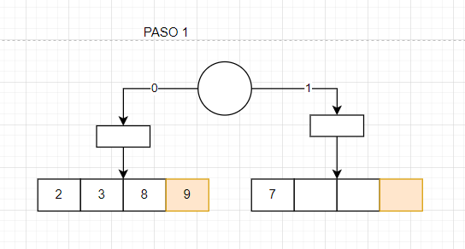

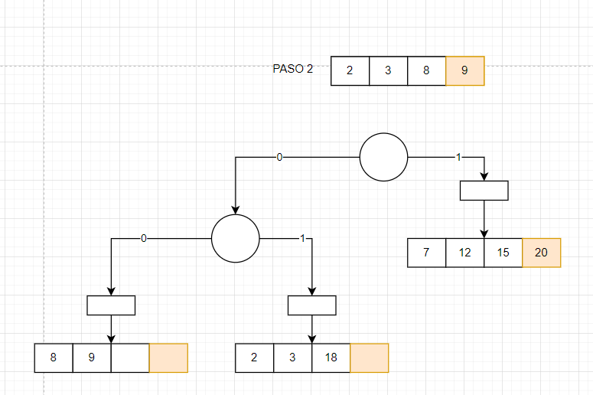

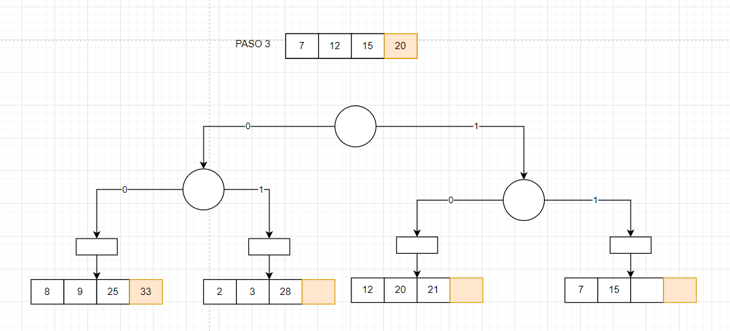

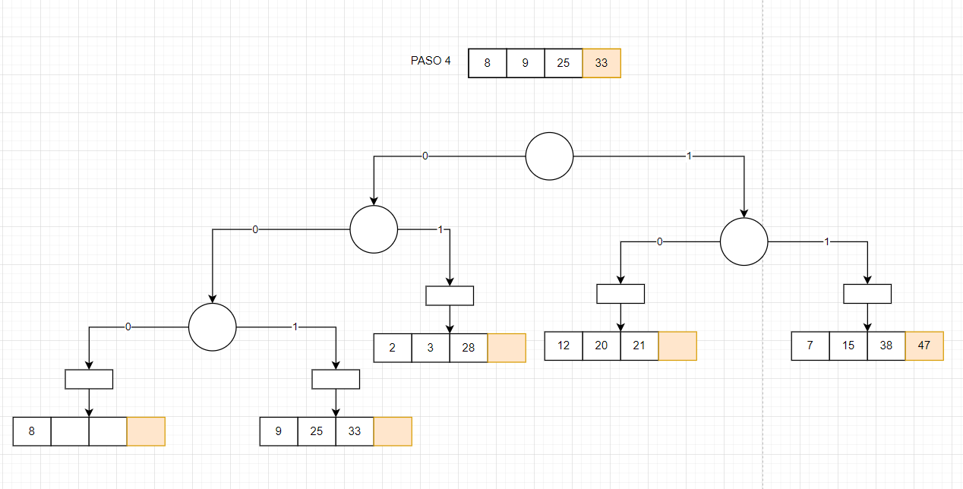

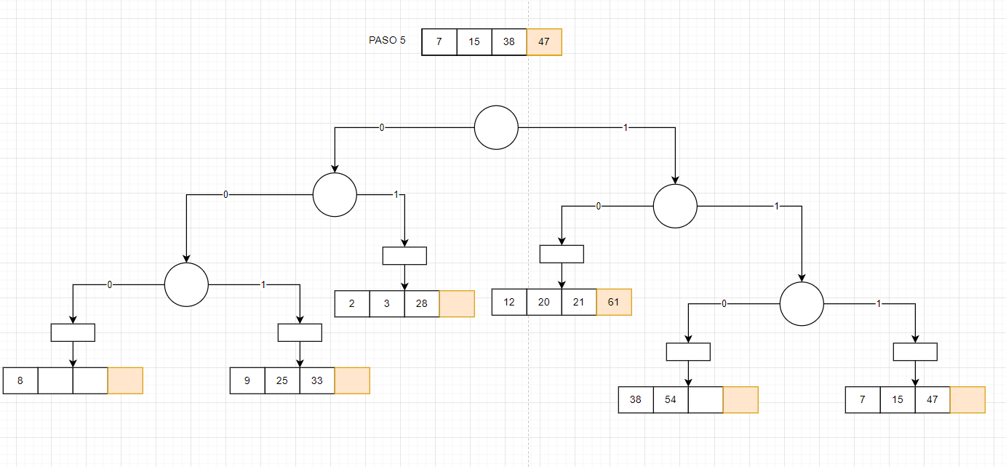

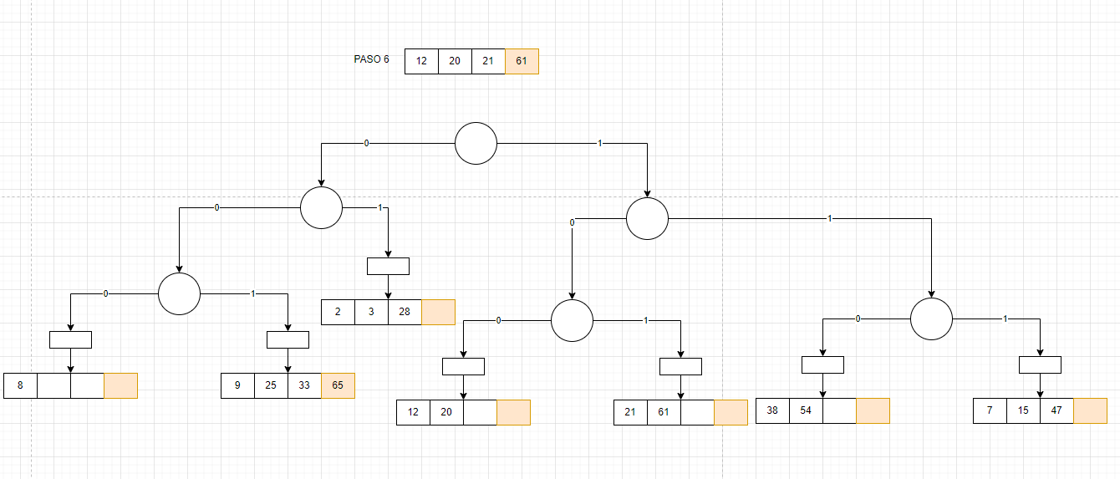

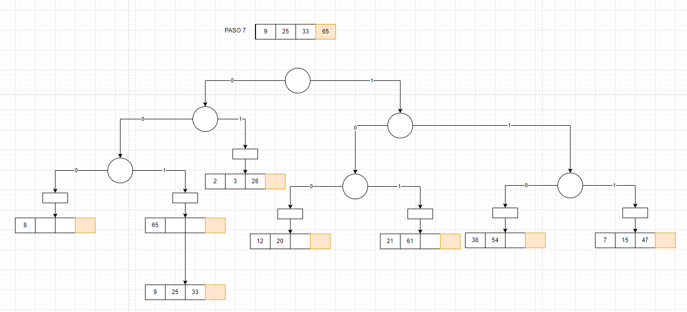

<https://drive.google.com/file/d/1E0hJyPne22rQzPz1t3XJKyRNb3_dHP0_/view?usp=sharing>